Kenneth P. Uhrick
1946 -

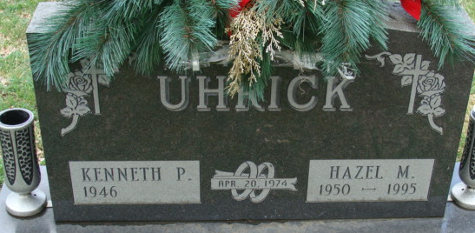
Photo by Alicia Kneuss

