Hazel M. (Ogan) Uhrick
June 11, 1950 – February 24, 1995

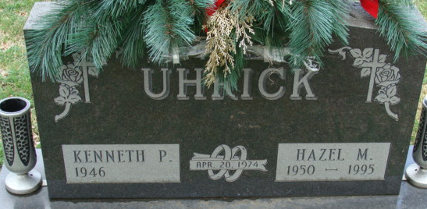
Photo by Alicia Kneuss

Hazel M. Uhrick, 44, of Decatur died yesterday at home. The Pennville native was a North Adams School System van driver for two years.
Surviving are her husband, Kenneth; a daughter, Stephanie M., at home; a son, Tony P., at home; her mother, Viola Ogan of Pennville; a sister, Rita Miller of rural Pennville; and a brother, Bob Ogan of rural Pennville.
Services are 11 a.m. Monday in Zwick-Sefton & Jahn Funeral Home, Decatur, where calling is from 11 a.m. to 4 p.m. and 6 to 9 p.m. tomorrow and 10 to 11 a.m. Monday. Burial will be in Decatur Cemetery.
Preferred memorials are gifts to Uhrick Children Scholarship Fund.

News-Sentinel, Allen County, Indiana
February 25, 1995

