Ernest D. “Beany” Uhrick
December 7, 1910 – November 5, 1986

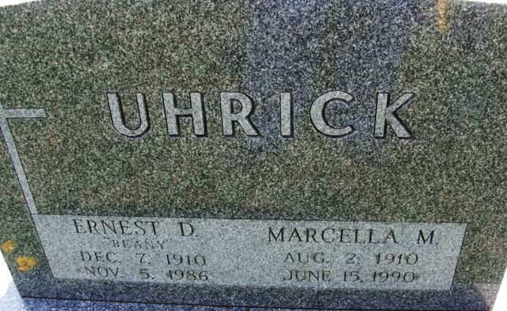
Photo by Alicia Kneuss

Florida Death Index, 1877-1998
Name: Ernest D Uhrick
Death Date: 5 Nov 1986; County of Death: Orange; State of Death: Florida Age at Death: 75; Race: White
Birth Date: 7 Dec 1910

**
Indiana, U.S., Marriages, 1810-2001
Name Ernest D Uhrick
Gender Male; Race White
Age 20
Birth Date 7 Dec 1910
Birth Place Craigville, Indiana
Marriage Date 24 Jul 1930
Marriage Place Indiana, United States
Residence Place Decatur, Indiana
Father Frank Uhrick
Mother Rosa Diehl
Spouse Marcella Nelson
Page 576

