Elmer Lewis Uhrick
December 10, 1928 – July 19, 2014

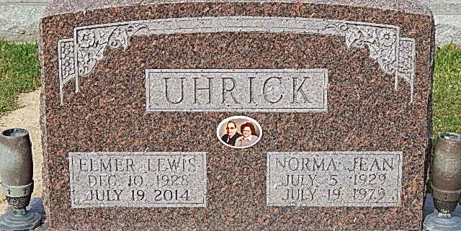
Photo by Alicia Kneuss

Elmer L. Uhrick, 85, of Bluffton, a lifelong resident of Adams and Wells counties, died at 2:30 p.m. Saturday, July 19, at Lutheran Hospital in Fort Wayne.
Mr. Uhrick worked at Franklin Electric for 25 years, retiring in 1991. He was known all around for being a great baker, especially for his chocolate chip and peanut butter cookies. He will always be remembered for being a great caretaker and loving grandfather to all of his grandchildren.
He was born Dec. 10, 1928, in Geneva, to Vernon Uhrick and Devota Clark Uhrick. He married Norma Jean Swygart Dec. 15, 1946, in Portland; she preceded him in death July 19, 1979. He married Madonna DuBois Bergdoll July 26, 1980, in Bluffton; she preceded him in death Aug. 27, 2001.
Survivors include two daughters, Joyce (Greg) Smith of Bluffton and Judy (Jerry) Wyatt of Warsaw; a son, Kerry (Marilyn) Uhrick of Sevierville, Tenn.; a daughter-in-law, Jane Uhrick of Wolcottville; two stepsons, Bill (Claudia) Bergdoll of Angola and Jim (Sheila) Bergdoll of Pickford, Mich.; three stepdaughters, Terri (Roger) Black, Cindy (Mike) Wolfe, and Ann (Jim) Harshman, all of Bluffton; 19 grandchild-ren, 40 great-grandchildren, and 29 great-great-grandchildren; a brother, Dale (Jane) Uhrick of Bluffton; and four sisters, Dollie Osborne of St. Louis, Mo., Josephine Hale of Decatur, and Ethel Flowers and Flossie Morris, both of Van Wert, Ohio.
He was preceded in death by a son, Larry Uhrick; two brothers, Clarence Uhrick and Walter Uhrick; and four sisters, Rebecca Beitler, Helen Diehl, Ola Uhrick, and Emma Lou Hires; and one great-great-grandchild.
Calling will be from 2 to 8 p.m. Wednesday at the Goodwin-Cale & Harnish Memorial Chapel and from 9 to 10 a.m. Thursday at the funeral home. Services will be held at 10 a.m. Thursday with Pastor Ryon Adcock officiating. Burial will be at the Decatur Cemetery. .
Preferred memorials are to the National Kidney Foundation.

Goodwin-Cale & Harnish Funeral Home, Wells County, Indiana
July 20, 2014

