Russell Uhlman
February 5, 1943 – April 8, 2015

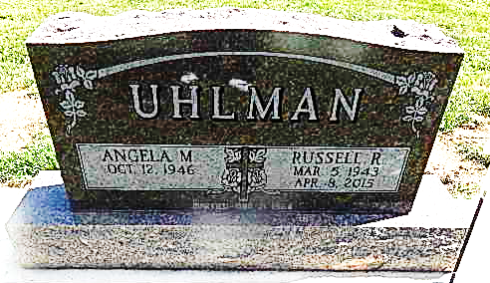

Russell R. Uhlman, 72, of Decatur passed away at Woodcrest Nursing Center on Wednesday, April 8, 2015. Russell was born on March 5, 1943 in Dover, IN to the late William and Virginia (Murtaugh) Uhlman. On March 21, 1964 he married Angela Abdon. Russell was a contractor for Biggs Inc.
He is survived by his wife of 51 years, Angela Uhlman of Decatur; two sons, Russell J. “Buck” (Misty) Uhlman of Wilmington, NC and Eric (Mindy) Uhlman of Decatur, IN; three daughters, Lisa Jones of Bloomington, IN, Shelly (Gary) Baker of Decatur, IN and Abby (Corey) De Roo of Monroe, IN; two brothers, John Uhlman of Arlington, VA and Harold Uhlman of Lawrenceburg, IN; a sister, Grace Murakami of Washington; 15 grandchildren and 3 great grandchildren. Russell was preceded in death by three brothers and a sister.
Visitation will be from Noon-4:00 p.m. Sunday, April 12, 2015 at Haggard-Sefton & Hirschy Funeral Home. Funeral Service will be at 10:00 a.m. Monday, April 13, 2015 also at the funeral home. Burial will be in Decatur Cemetery.
Memorials are to Family Life Care-Hospice or Tri County Dialysis.

Haggard & Sefton Funeral Home, Adams County, Indiana
April 9, 2015

