Elias Nathanial Tyrrill
September 6, 1852 – March 5, 1905

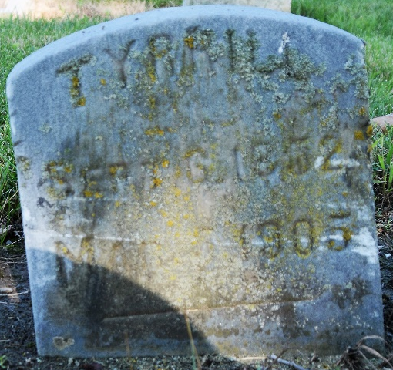
Photo by Deb Curry

Elias Nathanial Tyrrill
in the Indiana, U.S., Death Certificates, 1899-2017
Name Elias Nathanial Tyrrill
Gender Male
Race White
Marital Status Married
Age 52
Birth Date 6 Sep 1852
Birth Place Ohio
Death Date 5 Mar 1905
Death Place Decatur, Adams, Indiana, USA
Death Registration Date 1905
Father Johnathan Tyrrill
Mother Mary Jane Reader
Spouse Matilda A
Informant Matilda A. Tyrrill; Decatur, Indiana
Burial March 8, 1905; Maplewood Cemetery
**
Will of Elias N. Tyrrill
Name in Record, Reason for Being in Record, Date of Record
Elias N. Tyrrill of Decatur; makes his last will & testament Feb 24, 1905
Unnamed wife Inherits estate, including interest in blacksmith shop (E. N. Tyrrill & Co.)
C. M. Kenyon Witnessed Elias Tyrrill making his last will
J. W. Robinson Witnessed Elias Tyrrill making his last will
Elias N. Tyrrill Died March 5, 1905
C. M. Kenyon Subscribing witness
David Gerber Clerk; will has been admitted to probate March 16, 1905
Paul Baumgartner Deputy

