Mary (Heller) Tyndall
October 3, 1870 – June 28, 1966

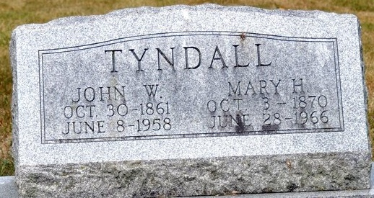
Photo by Deb Curry

Mrs. Mary Heller Tyndall, 95, widow of John W. Tyndall, and long prominent in church and social circles of Decatur, died at 12:45 p.m. today at the Adams County Memorial Hospital, where she had been a patient two years.
Survivors include a son, Dan Tyndall, and a sister, Miss Bertha Heller, both of Decatur.
The body was removed to the Zwick Funeral Home. Funeral arrangements have not been completed.
Decatur Daily Democrat; Adams County, Indiana
Tuesday, June 28, 1966

**
Indiana, U.S., Death Certificates, 1899-2011
Name: Mary Heller Tyndall
[Mary Heller Heller]
Gender: Female
Race: Caucasian (White)
Age: 95
Marital status: Widowed
Birth Date: 3 Oct 1870
Birth Place: Indiana
Death Date: 28 Jun 1966
Death Place: Decatur, Adams, Indiana, USA
Father: D D Heller
Mother: Anna Jane Corbus
Informant: Dan H. Tyndall; son; Decatur, Indiana
Burial: July 1, 1966; Decatur Cemetery; Decatur, Indiana

