Kathryn Anna (Egly) Tyndall
September 25, 1892 – January 24, 1974

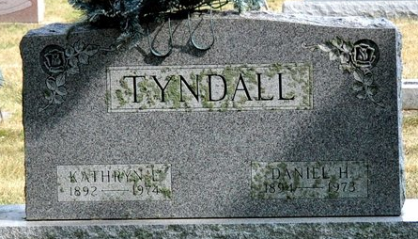
Photo by Deb Curry

Kathryn Tyndall, 81, Dies Today at Kokomo; Services are Saturday
Mrs. Kathryn E. Tyndall, 81, formerly of 404 Stratton Way and widow of Daniel H. Tyndall, died at 5:40 a.m. this morning in Turtle Creek Convalescent Home, Kokomo, following an extended illness.
The well-known lady, a prominent vocalist in this area for half a century, was a member of the First United Methodist Church, the Music Department of the Woman’s Club, Research Club, Tri Kappa, and was a 50-year member of the Order of Eastern Star. She was a past matron of the Eastern Star, past grand Esther, and past district deputy of district 14 in that organization.
Born in Berne on September 25, 1892, she was the daughter of Christian G. and Anna Shanebeck-Egly, and was married on August 16, 1916, to Daniel H. Tyndall, a Decatur businessman, who died Feb. 21, 1973. My Tyndall was associated with the Krick-Tyndall Tile Company.
Surviving are two daughters, Mrs. Chalmer (Mary Kathryn) Denny of Kokomo, and Mrs. Cloyd W. (Anna Jane) Rucker of Arlington, Rex.; one sister, Mrs. Lillian Latchaw of Findlay, O.; four grandchildren, Judith D. Firme, Nancy Rucker, Anna Kathryn Herndon and Robert B. Rucker, and two great-grandchildren. One brother preceded her in death.
Funeral services will be held at 2 p.m. Saturday at the Winteregg-Linn and Haggard Funeral Home, with Rev. Harold Leininger officiating. Burial will be in the Decatur Cemetery. Friends may call at the funeral home after 4 p.m. Friday. The Order of Eastern Star will hold services at 7:30 p.m. Friday.

Decatur Daily Democrat, Adams County, IN
Thursday, January 24, 1974

