John Wilson Tyndall
October 30, 1861 – June 8, 1958

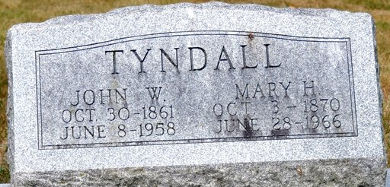
Photo by Deb Curry

John W. Tyndall
in the Indiana, U.S., Death Certificates, 1899-2017
Name John W. Tyndall
Gender Male
Race White
Marital Status Married
Age 96
Birth Date 30 Oct 1861
Birth Place Indiana
Death Date 8 Jun 1958
Death Place Decatur, Adams, Indiana, USA
Death Registration Date 1958
Father John C. Tyndall
Mother Rachel Wagers
Informant Mrs. Mary Tyndall; wife; Decatur, Indiana
Burial June 11, 1958; Decatur Cemetery; Decatur, Indiana
**

JOHN WILSON TYNDALL, surveyor of Adams County, Indiana, is a native of this county, born in Blue Creek Township, October 30, 1861, a son of John C. and Rachael (Wagers) Tyndall, natives of Ohio, the father of Welsh and the mother of German-Irish descent. His paternal ancestors came to America prior to the war of the Revolution and were prominent in the early days of American history. John C. Tyndall was reared a farmer, and in 1850 located in Adams County, Indiana, being one of the first settlers of Blue Creek Township. He improved a farm, and in the earlier days of the county taught about twelve terms of school during the winter. In 1861 he enlisted in the defense of the Union, and was assigned to Company I, Forty-seventh Indiana Regiment, and served nearly two years, when he was discharged for disability. He never recovered his former health, and his death which occurred July 2, 1885, was the result of sickness contracted in the army. Politically he was a Democrat. He was a prominent citizen of his township, and served several terms as assessor, and twelve years as justice of the peace. The mother of our subject died in 1865, when he was but four years of age.
J. W. Tyndall was reared in Blue Creek Township, where he received the rudiments of his education. When sixteen years old he began teaching, and when seventeen bought his time of his father, paying him $100 a year until he was twenty-one. In 1882 he entered the college proper St Valparaiso, and graduated from the commercial, scientific and classical departments, completing the latter with the class of 1885. He is self-educated, earning the money to defray the expenses of his college course by teaching. Upon leaving school it was his intention to go to Kansas and engage in teaching, a vocation for which he is so eminently fitted, but the death of his father obliged him to remain in Adams County to settle up the estate, and in March, 1886, he was the nominee of the Democratic party for county surveyor, to which office he was elected by a large majority the following November. Mr. Tyndall is a young man of fine ability, and his prospects for future usefulness are promising. His career thus far has been marked with success, and he is well fitted to assume any duties the future may have in store for him.

Biographical and Historical Record - Adams and Wells Co. Indiana Lewis Publishing Co. Chicago, IL 1887

