Marylene (Bonifas) Tutewiler
March 17, 1924 – April 13, 2016

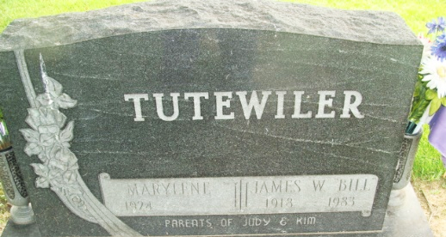
Photo by Alicia Kneuss

Marylene Tutewiler, 92, of Decatur, IN, passed away on Wednesday, April 13, 2016 at Adams Woodcrest. Marylene was born on March 17, 1924 in Delphos, Ohio to the late Phillip and Violet (Willison) Bonifas. On October 30, 1943, she married James William “Bill” Tutewiler; he preceded her in death on July 2, 1983.
Marylene was a member of Zion United Church of Christ. She was involved in various organizations at Zion, most notably playing the piano and teaching in the Nursery and the Kindergarten Department. She served on the Community and Family Services Board, Operation Help Board, and the Traveling Board. She also volunteered for the Red Cross Bloodmobile and helped with the Girl Scouts. She worked as a lifelong homemaker and also helped her husband at D&T Standard Service.
She served as Secretary for the Adams County Bowling League. She was an accomplished bowler and is listed in the Adams County Hall of Fame. She was an avid golfer.
She is survived by 2 daughters, Judy K. (Max) Eichenauer of Decatur and Kimberly A. (Greg) Burtsfield of Elkhart, IN; 2 grandsons, Jeff (Deanna) Eichenauer of Schaumburg, IL and Kyle (Shannon) Eichenauer of Decatur; 3 great granddaughters, Ashley, Abigail, and Annabelle Eichenauer. She was preceded in death by a brother, Hollis Bonifas and 2 sisters, Thelmalene Bonifas (infant) and Phyllis Shaffer.
Visitation will be on Thursday, April 21, 2016 from 10:00 a.m. - 12:00 p.m. at Woodcrest Porter Auditorium and from 3:00 - 7:00 p.m. at Haggard-Sefton & Hirschy Funeral Home
A Funeral Service will be held at 10:30 a.m. on Friday, April 22, 2016 at Zion United Church of Christ, with calling 1 hour prior from 9:30 - 10:30 a.m. Officiating will be The Rev. Randy Rossman and burial will take place in the Decatur Cemetery.
Memorials may be made to Zion U.C.C.
Haggard-Sefton & Hirschy Funeral Home, Adams County, Indiana
April 14, 2016

