James W. Tutewiler
December 6, 1918 – July 2, 1983

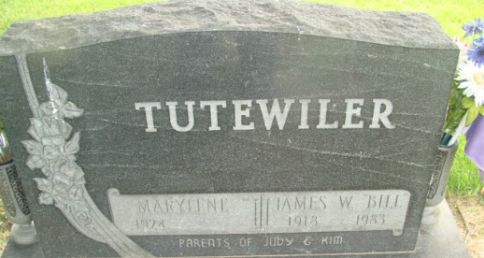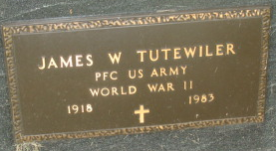
Photo by Alicia Kneuss

James W. Tutewiler
in the Indiana, U.S., Death Certificates, 1899-2017
Name James W. Tutewiler
Gender Male
Race White
Marital Status Married
Age 64
Birth Date 6 Dec 1918
Birth Place Illinois
Death Date 2 Jul 1983
Death Place Fort Wayne, Allen, Indiana, USA
Death Registration Date 1983
Father Simmual Tutewiler
Mother Carrie E. Evett
Spouse Marylene Bonifas
Informant Marylene Tutewiler; wife; Decatur, Indiana
Burial July 5, 1983; Decatur Cemetery; Decatur, Indiana

