Wanda Louise Tumbleson
February 28, 1920 – April 3, 1925

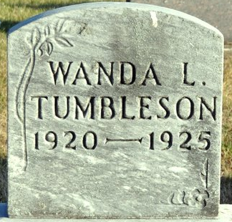
Photo by Deb Curry

Manela Louise Tumbleson
in the Indiana, U.S., Death Certificates, 1899-2017
Name Wanda Louise Tumbleson
Gender Female
Race White
Marital Status Single
Age 4
Birth Date 28 Feb 1921 (sic)
Birth Place Fort Wayne, Indiana
Death Date 3 Apr 1925
Death Place Decatur, Adams, Indiana, USA
Death Registration Date 1925
Father Delbert H. Tumbleson
Mother Edna Steele
Informant D. H. Tumbleson; Fort Wayne, Indiana
Burial April 6, 1925; Decatur, Indiana

