Robert Donald Tumbleson
March 28, 1918 – September 4, 1919

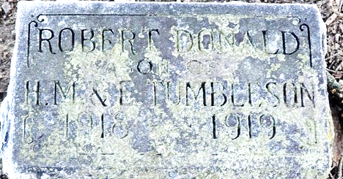
Photo by Deb Curry

Babe Dies of Cholera Infantum
DECATUR, Ind., Sept. 6 – Robert D. Tumbleson, little son of Mr. and Mrs. Harley Tumbleson, of Union Township, died Thursday afternoon after an illness of six days of cholera infantum, at the age of 1 year, 5 months and 6 days.
Besides the mother and father, the child is survived by a sister, Helen, and brother, Millard.
Funeral services were held at Clark's Chapel, Union Township, this morning, followed by interment in the Maplewood Cemetery at Decatur.
Unknown source
**
Indiana, U.S., Death Certificates, 1899-2017
Name Robert Donald Tumbleson
Gender Male
Race White
Marital Status Single
Age 1
Birth Date 28 Mar 1918
Birth Place Union Tp., Adams Co, Indiana
Death Date 4 Sep 1919
Death Place Union Twp., Adams, Indiana, USA
Death Registration Date 1919
Father Harley M. Tumbleson
Mother Eley Gay
Informant Harley M. Tumbleson; Monroeville, Indiana
Burial September 6, 1919; Decatur Cemetery
**
Zwick Funeral Home Records 1918-1922
Name of Deceased Robert Donald Tumbleson
Casket No. #303 Indianapolis Casket Co.; Size 3' 0"; $35.00
Handles #172; 4
Lining & Pillow Set 2 2/3 yds.;
Metal Vault Style Clark Vac.; $65.00
Mountings Plate #7012
Flowers Spray for Tumbleson family; $3.00
Date of Funeral September 6, 1919; 9:30 a.m.
Date of Death September 04, 1919
Place of Death Union Township, Adams County, Indiana
Place of Funeral Union Chapel Church
Clergyman Rev. Silverson
Date of Burial September 06, 1919
Where Interred Decatur Cemetery
Color White
Status Single
Birthplace Union Township, Adams County, Indiana
Last Place of Residence Union Township, Adams County, Indiana
How Long Resident of This State Life
Father's Name Harley M. Tumbleson
Country of Birth Huntington County, Indiana
Mother's Name Edey Gay
Country of Birth St. Mary's Township, Adams County, Indiana
Physician Dr. Clarence Cowan
Cause of Death Cholery Infantion
Ordered By Harley M. Tumbleson
Charge To Harley M. Tumbleson
When Rendered September 06, 1919
Received on Account September 5, 1919; by cash per ??; $3.00
Received on Account January 20, 1920; by check; $50.00
Received on Account October 9, 1920; by check; $50.00 (PAID $103.00)

