P. Douglas Tumbleson
August 18, 1951 – August 27, 2017

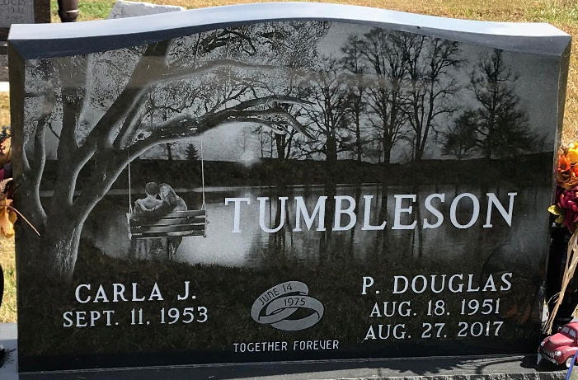
Photo by PLS

Douglas "Doug" Tumbleson, 66, of Decatur, Indiana passed away Sunday, August 27, 2017 at Adams Memorial Hospital ER. He was born on Saturday, August 18, 1951 in Decatur, Indiana the son of Charles and Norma (Liechty) Tumbleson. He married Carla J. Cook on June 14, 1975 at Pleasant Mills United Methodist Church.
Doug retired from Ferguson Fire in Fort Wayne with 14 years of service and prior to that was employed at Automatic Sprinkler in Monroe for 26 years. He also worked part-time at Helena in Monroe & Berne and Sohigro in Berne. He was a member of the Plumbers & Pipefitters Union #166.
He was a member of Pleasant Mills United Methodist Church where he served on several committees, was the Sunday school treasurer, & was the song leader. Doug loved gospel music and was in charge of scheduling quartet groups for the annual church homecoming.
He enjoyed spending time with his grandkids and watching their sporting events. He loved all sports and tinkering around in his garage. Doug also enjoyed the holidays and family get-togethers playing board games and card games.
Survivors include his wife, Carla J. Tumbleson of Decatur; two daughters, Sara (Kerry) Hedington of Monroe & Katie Tumbleson of Decatur; son, Joseph (Sarah) Tumbleson of Decatur; niece, Abbey Tumbleson of Berne; & five grandchildren, Klarissa, Desiree & Miranda Hedington; & Dallas & Ethan Tumbleson. He was preceded in death by his parents; a brother, Steven Tumbleson and his in-laws, Richard and Lois (Bauman) Cook.
Funeral services will be held at 10:30 a.m. Thursday, August 31, 2017 at Zwick & Jahn Funeral Home in Decatur with Pastor Tammy K. Lugar & Karen Garner officiating. Interment will follow in the Decatur Cemetery.
Friends will be received from 5 to 7 p.m., Wednesday, August 30 at Zwick & Jahn Funeral Home in Decatur & one hour prior to the service on Thursday at the funeral home.
Preferred memorials are to ACCF - Paul & Kathryn Strickler Oncology Facility.
Zwick & Jahn Funeral Home, Adams County, Indiana
August 28, 2017

