Margery Kathryn Tumbleson
February 15, 1922 – February 17, 1922

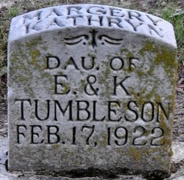
Photo by Deb Curry

FUNERAL THIS AFTERNOON
Funeral services for Margery Kathryn, infant daughter of Mr. and Mrs. Ernest Tumbleson, who was born last Wednesday and passed away last evening, will be held this afternoon at 1:30 o’clock at the home four miles east of this city. Interment will be made in the Decatur Cemetery.
Decatur Daily Democrat, Adams County, Indiana
Saturday, February 18, 1922
**
Indiana, U.S., Birth Certificates, 1907-1944
Name Marjorie Katherine Tumbleson
Gender Female
Birth Date 15 Feb 1922; Birth Place St. Marys, Adams, Indiana, USA
Father Ernst Tumbleson; age 35
Mother Katherine Kitson; age 29; 2nd child, both living
Certificate Number 5880; Roll number 40474_357248
Volume Range 11 – 15

**
Indiana, U.S., Death Certificates, 1899-2017
Name Margory Catharine Tumbleson
Gender Female; Race White; Marital Status Single
Age 2 days
Birth Date 15 Feb 1922; Birth Place St Mary Tp Adams Co Indiana
Death Date 17 Feb 1922; brain injury at birth
Death Place Saint Marys, Adams, Indiana, USA
Father Earnest Tumbleson
Mother Catharine J Kitson
Informant Earnest Tumbleson; Decatur, Indiana
Burial February 18, 1922; Decatur Cemetery

