Lyle D. Tumbleson
January 19, 1933 – June 10, 1955

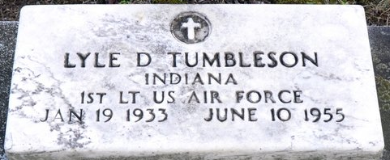
Photo by Deb Curry

First Lt. Lyle D. Tumbleson, 22, son of Mr. and Mrs. Harley M. Tumbleson of Jefferson Township, Geneva Route 2, was one of 10 American airmen who were killed when a U.S. Air Force Super Fortress smashed into a German mountainside Friday night. All on board the plane perished.
The parents received word of their son’s death Saturday afternoon in a telegram from Brig. Gen R. J. Reeves, director of Military Personnel, Headquarters U. S. Air Force, Washington, D. C. The telegram said that the department regrets to inform them of the death of their son in the crash. A follow-up telegram arrived Saturday evening, a few hours after the first telegram. Members of the Tumbleson family were unaware that the plane had crashed.

Adams County Historical Museum, Adams County, Indiana
March 1955 – April 1958 Scrapbook, image 16
Handwritten date: Monday, June 13, 1955

**
FUNERAL SERVICES FOR VICTIM OF AIRPLANE CRASH
Body of Lt. Tumbleson Arrives Here Saturday Morning
Funeral Services will be held at 2:00 p.m. Tuesday at the Mount Carmel E.U.B. Church, southeast of Berne, of which he was a member. Rev. Lawrence Feaver, pastor of the church, and Rev. Lawrence Norris, pastor of the Union Chapel Church near Decatur, will officiate and burial will be in the Decatur Cemetery where military services will be in charge of Rev. Mr. Norris.
The Adams County young man was killed Friday, June 10. The body of Lt. Tumbleson arrived ??. From here it was taken to the home of Lt. Tumbleson’s parents, Mr. and Mrs. H. M. Tumbleson in Jefferson Township, 3 ½ miles east and 3 miles south of Berne, where friends may call up until time for the funeral.
The young man was born in Jefferson Township January 19, 1933, the son of Harley M. and Eda Gay Tumbleson.
Surviving are the parents and the following sisters and brothers: Mrs. Victor (Mildred) Kuhn, Berne; Mrs. Robert (Bernice) McBride, Decatur; Paul and Dale Tumbleson, and Mrs. Ruth Wispliere, all of Fort Wayne; Harley Tumbleson, Jr., Geneva (rest is missing).

Adams County Historical Museum, Adams County, Indiana
March 1955 - April 1958 Scrapbook, image 16
Handwritten date: Monday, June 27, 1955

