Kathryn I. (Kitson) Tumbleson
February 2, 1893 – December 23, 1967

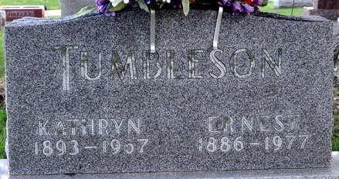
Photo by Deb Curry

Kathryn I Tumbleson
in the Indiana, U.S., Death Certificates, 1899-2017
Name Kathryn I Tumbleson
[Kathryn I Kitson]
Gender Female
Race White
Marital Status Married
Age 74
Birth Date 2 Feb 1893
Birth Place Indiana
Death Date 23 Dec 1967
Death Place Decatur, Adams, Indiana, USA
Death Registration Date 1967
Father William Kitson
Mother Margaret A Stoneburner
Informant Ernest Tumbleson; husband; Decatur, Indiana
Burial December 27, 1967; Decatur Cemetery; Decatur, Indiana

