James K. Tumbleson
September 3, 1846 – September 15, 1919

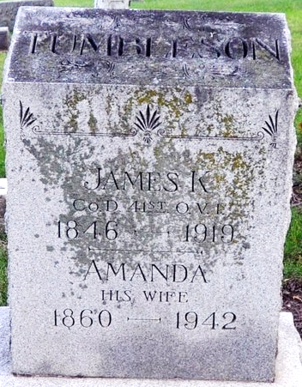
Photo by Deb Curry

James K. Tumbleson
in the Indiana, U.S., Death Certificates, 1899-2017
Name James K. Tumbleson
Gender Male
Race White
Marital Status Married
Age 73
Birth Date 3 Sep 1846
Birth Place Adams Co., Ohio
Death Date 15 Sep 1919
Death Place Decatur, Adams, Indiana, USA
Death Registration Date 1919
Father Soloman Tumbleson
Mother Greenwood
Spouse Amanda E. Long
Informant Mrs. Amanda Tumbleson; Decatur, Indiana
Burial September 17, 1919; Decatur Cemetery
**
Civil War Service

James Tumbleson
Residence was not listed
18 years old.
Enlisted on 9/30/1864 as a Private. On 9/30/1864 he mustered as a substitute into "D" Co. OH 41st Infantry.
He was Mustered Out on 6/13/1865 at Nashville, TN.

**
Zwick Funeral Home Records 1918-1922
Name of Deceased James K. Tumbleson
Casket No. #3805 1/4 R10 Int 144; National Casket Co.; Size 6' 3"; $200.00
Handles H 5-6; Silveroid; Metal Vault Style Acker Cement; $60.00
Burial Robe # 4596; $25.00; Slippers #9; $3.00
Flowers Reath [sic] with star in center; $7.00
Date of Funeral September 17, 1919; 2:30 p.m.
Date of Death September 15, 1919
Place of Death Decatur, Indiana; 318 Maple St.
Place of Funeral M. E. Church, Decatur
Date of Burial September 17, 1919
Where Interred Decatur Cemetery
Born September 3, 1846
Age 73 years, 0 months, 12 days
Color White; Occupation Farmer; Status Married
Birthplace Adams County, Indiana
Last Place of Residence Decatur, Indiana; 318 Maple St.
How Long Resident of This State Life
Husband's/Wife's Name Amanda E. Long
Father's Name Solomon Tumbleson b. Ohio
Mother's Name Greenwood b. Ohio
Physician Dr. S. D. Beavers
Ordered By Mrs. Amanda E. Tumbleson
Charge To Mrs. Amanda E. Tumbleson
When Rendered September 17, 1919
Received on Account September 19, 1919; by check; $220.00
Received on Account October 15, 1919; by ?; $75.00 (PAID $295.00)

