Helen Lorene Tumbleson
April 28, 1916 – December 20, 1933

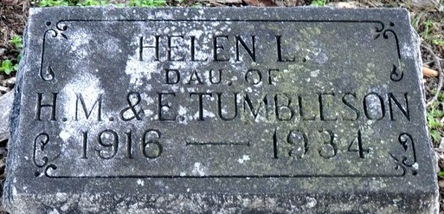
Photo by Deb Curry

Indiana, U.S., Death Certificates, 1899-2011
Name: Helen Lorene Tumbleson
Gender: Female
Race: White
Age: 17y 7m 22d
Marital status: Single
Birth Date: 28 Apr 1916
Birth Place: Indiana
Death Date: 20 Dec 1933
Death Place: Jefferson, Adams, Indiana, USA
Father: Harley Tumbleson, informant
Mother: Edna Gay
Burial: Dec. 22, 1933, Decatur

