Ernest Tumbleson
April 15, 1886 – August 17, 1977

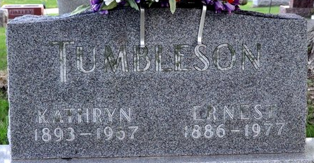
Photo by Deb Curry

ERNEST TUMBLESON
Ernest Tumbleson, 91, of route 4, Decatur, a retired farmer and former employe of the Adams County and Indiana highway departments, died at 2:35 p.m. Wednesday afternoon at the Adams County Memorial Hospital, where he had been hospitalized three weeks.
Mr. Tumbleson was a member of the St. Mark's United Methodist Church, and served as Republican precinct committeeman in Root township for more than 20 years.
Born in Huntington County on April 15, 1886, he was the son of James and Amanda Long-Tumbleson, and was united in marriage on Dec. 14, 1912 to (cut off) ...died Dec. 23, 1967.
Survivors include one son, Cedric Tumbleson, Decatur; two daughters, Mrs. Robert (Norma) Lord, route 4, Decatur and Mrs. Bennet (Alice) Kemp, Fort Wayne; two sisters, Mrs. Harry (Ethel) Essex, Decatur and Mrs. Hazel Kortenber, Fort Wayne and one brother, Delbert Tumbleson; five grandchildren and four great-grandchildren. One daughter, two sisters, and five brothers preceded him in death.
Funeral services will be conducted Saturday at 2 p.m. at the Winteregg-Linn & Haggard Funeral Home, with Rev. C. Albert Nunery officiating. Burial will be in the Decatur Cemetery. Friends may call at the funeral home (cut off)

Decatur Daily Democrat, Adams County, Indiana
August 18, 1977

**
Indiana, U.S., Death Certificates, 1899-2017
Name Ernest Tumbleson
Gender Male
Race White
Age 91
Marital Status Widowed
Birth Date 15 Apr 1886
Birth Place Indiana
Death Date 17 Aug 1977
Death Place Decatur, Adams, Indiana, USA
Death Registration Date 1977
Father James Tumbleson
Mother Amanda Long
Informant Mrs. Robert Lord; daughter; Decatur, Indiana
Burial August 20, 1977; Decatur Cemetery; Decatur, Indiana

