Edna Belle (Steele) Tumbleson
December 24, 1887 – January 12, 1988

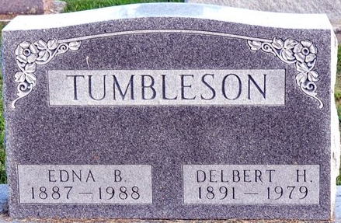
Photo by Deb Curry

Edna B Tumbleson,100, died at 6 a.m. Tuesday in Convoy Care Center, Convoy, Ohio. Her husband, Delbert H. died in 1979. She was a homemaker.
Surviving is a daughter, Frances Newby of Decatur, two sisters, and one granddaughter.
Services at 1:30 p.m. Friday at Zwick-Sefton & Jahn Funeral Home; calling 2 to 9 p. m. Thursday.
Memorials to Convoy Care Center.
Journal Gazette, Allen County, Indiana
Wednesday, January 13, 1988
**
U.S., Social Security Applications and Claims Index, 1936-2007
Name Edna Belle Tumbleson
[Edna B Tumbleson]
[Edna Belle Steele]
Gender Female
Race White
Birth Date 24 Dec 1887
Birth Place Pleasant Mills, Indiana
Death Date 12 Jan 1988
Father Jessie H Steele
Mother Niffie B Cowan
SSN xxx
Death Certificate Number 27167006405
Notes 13 Sep 1972: Name Listed As Edna Belle Tumbleson; 22 May 1998: Name Listed As Edna B Tumbleson

