Dorothy Irene (Ross) Tumbleson
August 8, 1927 – October 23, 2017

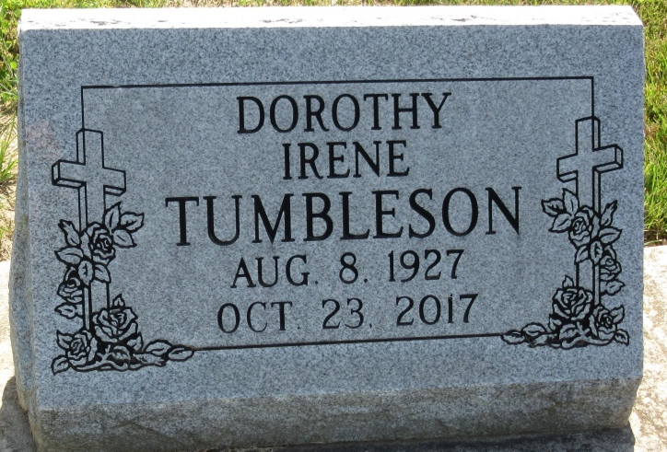
Photo by PLS

Dorothy I. Tumbleson, 90, of Decatur, Indiana (formerly of Berne, IN) passed away on Monday, October 23, 2017 at Woodcrest Nursing Facility. She was born on August 8, 1927 to the late Bruce Lee and Beatrice Lulu (Krugh) Ross in Mercer County, OH. On June 13, 1947 she married Harley J. Tumbleson on June 13, 1947. He passed away on April 2, 2010.
She was a member of the First Missionary Church in Berne and the American Legion Post #468 of Berne. She was a Homemaker and employed by CTS of Berne for 31 years. Dorothy and her late husband organized the first Muscular Dystrophy Association in Adams County.
She is survived by 1 son, Darrell W. Tumbleson of Melbourne, FL; 3 daughters, Carol Baugher of Ft. Wayne, IN, Mrs. Janis (Ralph) Haggard of Wolcottville, IN, Mrs. Genise (Jimmie) Carriere of Houston, TX; 3 brothers, Ken Ross of Willshire, OH, Lanny (Mary Ellen) Ross of Ft. Wayne, IN, Paul Ross of Convoy, OH; 1 sister, Rosemary Charleston of Van Wert, OH; 8 grandchildren and 5 great grandchildren. Dorothy was preceded in death by her husband; 1 daughter, Joyce Williams who passed away in 1994 and 2 brothers.
Visitation will be held from 11:00 a.m. – 2:00 p.m. on Saturday, October 28, 2017 at Haggard-Sefton & Hirschy Funeral Home.
A Funeral Service will follow at 2:00 p.m. at Haggard-Sefton & Hirschy Funeral Home with Chap. Jeff Lutrell officiating. Burial will take place at the Decatur Cemetery.
In lieu of flowers you may give to the Muscular Dystrophy, Parkinson’s Disease or Gideon’s.

Haggard & Sefton Funeral Home, Adams County, Indiana
October 25, 2017

