Delbert H. Tumbleson
September 11, 1891 – December 1, 1979

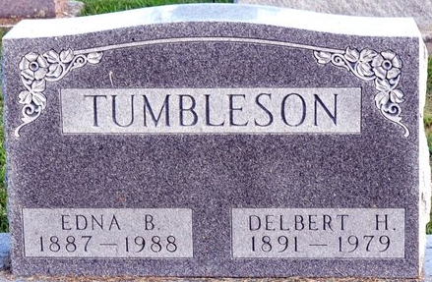
Photo by Deb Curry

Delbert H. Tumbleson, 88 route 6, Decatur, on Salem Road, died at 10:50 pm Saturday at Adams County Memorial Hospital, where he had been a patient for 12 hours.
He was a retired employee of the Wayne Home Equipment Co., of Fort Wayne, and a member of the Pleasant Mills united Methodist Church.
Born in Adams Co., on September 11, 1891, he was the son of James and Amanda Long-Tumbleson, and was married on June 17, 1916, to Edna Steele who survives. The couple was married for 63 years.
Survivors include one daughter, Mrs. Charles (Frances) Newby, route 6, Decatur, with whom he made his home; one sister, Mrs. Hazel Kortenber, Fort Wayne; one granddaughter, and three great-grandchildren. One daughter Wanda, one grandson, six brothers and 3 sisters preceded him in death.
Burial at Decatur Cemetery.
Decatur Daily Democrat, Adams County, Indiana
December 3, 1979

