Cedric J. Tumbleson
May 22, 1914 – March 23, 1979

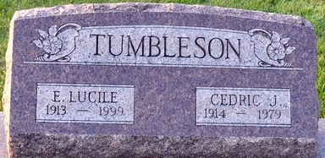
Photo by Deb Curry

Cedric J. Tumbleson, 64, of 128 South 13th St., a retired Krick-Tyndall employee, died at 2:08 a.m. today at the Fort Wayne Lutheran Hospital. He had been in poor health for 10 years and retired a decade ago.
He was born in Adams County on May 22, 1914, a son of Ernest and Kathryn Kitson-Tumbleson and was married on April 16, 1954 to E. Lucile McQuown, who survives.
Also surviving are one son, Robert Zerby, route 1, Geneva; two sisters, Mrs. Robert (Norma) Lord, Decatur; Mrs. Bennett (Alice) Kemp, Fort Wayne; three grandchildren and two great-grandchildren.
Funeral services for Mr. Tumbleson, who was also a retired farmer, will be held Monday at 10:30 a.m. at the Zwick Funeral Home, with Rev. C. Albert Nunery officiating. Burial will be in Decatur Cemetery. Friends may call at the funeral home after 7 p.m. Saturday.
Preferred memorials are to the cancer society.
Decatur Daily Democrat, Adams County, Indiana
Friday, March 23, 1979
**
CEDRIC J. TUMBLESON
Funeral services for Cedric J. Tumbleson, 64, of 128 South 13th st., will be held Monday at 10:30 a.m. at the Zwick Funeral Home, with burial in the Decatur Cemetery. Friends may call at the Zwick Funeral Home after 7 p.m. today.
Mr. Tumbleson died at 2:08 p.m. Friday at the Parkview Memorial Hospital, not Lutheran Hospital, as was reported to the Democrat.
He was a member of the St. Mark's United Methodist Church.
Decatur Daily Democrat, Adams County, Indiana
Saturday, March 24, 1979

