Carla J. (Cook) Tumbleson
September 11, 1953 -

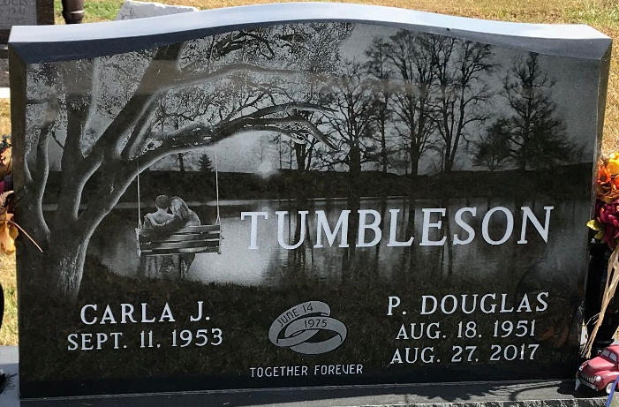
Photo by PLS

