Amanda E. (Long) Tumbleson
June 8, 1860 – February 7, 1942

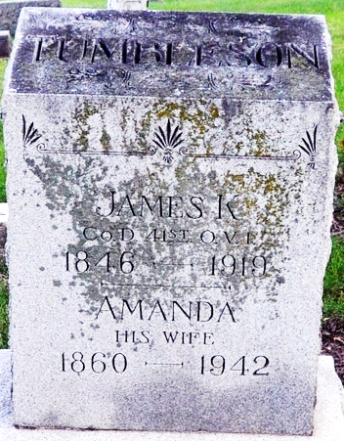
Photo by Deb Curry

TUMBLESON FUNERAL SERVICES TUESDAY
Decatur Woman Dies After Long Illness
Funeral services will be held Tuesday afternoon at 2 o'clock at the home and 2:30 o'clock at the First Methodist Church for Mrs. Amanda Tumbleson, 81, who died Saturday night at 6:10 o'clock at her home, 318 Maple Street, Decatur.
Death was caused by complications following an extended illness. She had been an invalid since 1929.
Mrs. Tumbleson was born in Columbia City June 8, 1860, the daughter of Jacob and Sarah Dinius Long. She was a member of the First Methodist Church and of the GAR auxiliary. Her husband James K. Tumbleson, died in 1919.
Surviving are the following children: Ernest of near Decatur, Mrs. Charles A. Fuhrman of Preble, Delbert of Fort Wayne, Harley M. of Geneva, Mrs. Joseph Kortenber of Decatur, Miss Ethel Tumbleson at home, Mrs. Calvin Markey of Sidney and Anthony J. of Fort Wayne. Three sons and a sister are deceased. Thirty-five grandchildren and 14 great-grandchildren also survive.
The body has been returned to the residence from the Zwick Funeral Home. It may be viewed there until time for the services. Rev. R. W. Graham will officiate at the services.
Decatur Daily Democrat, Adams County, Indiana
Monday, February 9, 1942

