Roy Rudolph Tschannen
January 30, 1910 – August 11, 1977

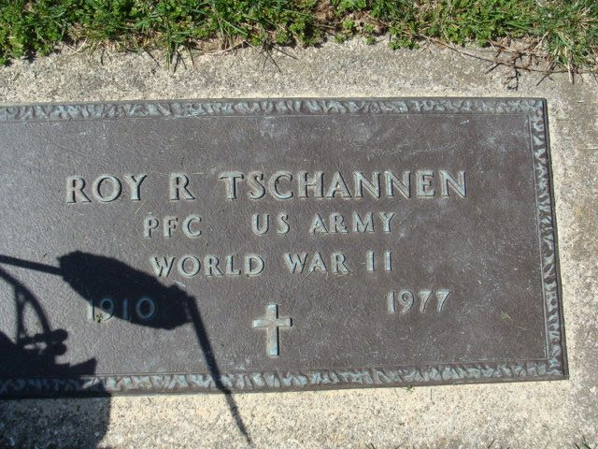
Photo by Alicia Kneuss

Roy Rudolph Tschannen
in the Indiana, U.S., Death Certificates, 1899-2017
Name Roy Rudolph Tschannen
Gender Male
Race White
Marital Status Never Married (Single)
Age 67
Birth Date 30 Jan 1910
Death Date 11 Aug 1977
Death Place Decatur, Adams, Indiana, USA
Death Registration Date 1977
Father John Tschannen
Mother Mary Tonner
Informant Homer Tschannen; brother; Decatur, Indiana
Burial August 13, 1977; Decatur Cemetery; Decatur, Indiana

