Jacob J. Tschannen
October 16, 1912 – August 17, 1982

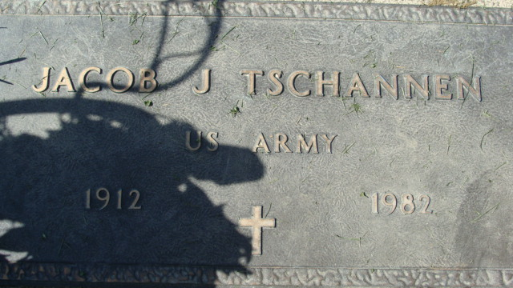
Photo by Alicia Kneuss

Jacob J. Tschannen
in the Indiana, U.S., Death Certificates, 1899-2017
Name Jacob J. Tschannen
Gender Male
Race White
Marital Status Never Married (Single)
Age 65
Birth Date 16 Oct 1912
Birth Place Indiana
Death Date 17 Aug 1982
Death Place Decatur, Adams, Indiana, USA
Death Registration Date 1982
Father John Tschannen
Mother Mary Turner [sic - Tonner]
Informant Orel Tschannen; brother; Geneva, Indiana
Burial August 23, 1982; Decatur Cemetery; Decatur, Indiana

