Rebecca (Connett) True
July 1, 1826 – March 26, 1902

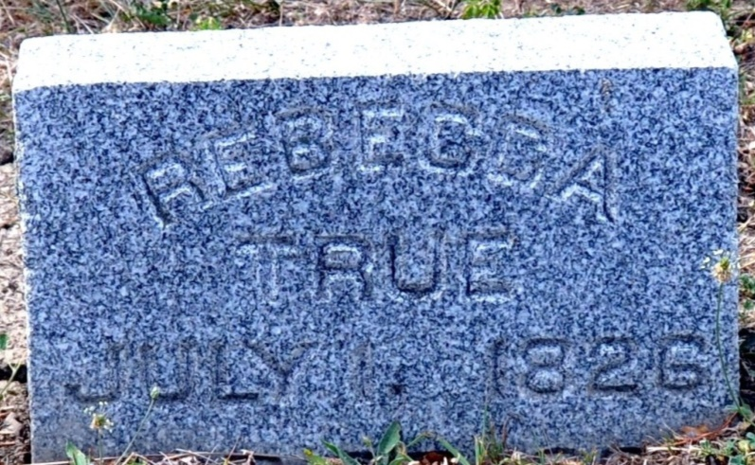
Photo by Deb Curry

The death of Mrs. Rebecca True occurred at 11 o'clock last night. Her health had apparently been good until an early hour Sunday morning when she suffered a stroke of paralysis from which she never recovered at all, but gradually grew worse until death resulted. She had reached the extreme age of seventy-six years.
Friends wishing may view the remains at the home of C. F. True, with whom she lived, at any time. The funeral services will take place from the Methodist church tomorrow, Friday, at three o'clock. Interment in Maplewood.

Decatur Democrat; Adams County, Indiana
A weekly newspaper
Thursday, March 27, 1902

**
Indiana, U.S., Death Certificates, 1899-2011
Name: Rebecca True
[Rebecca Connett]
Gender: Female
Race: White
Age: 75 years, 6 months, 25 days
Marital status: Widow
Birth Date: abt 1827
Birth Place: Athens Co-Ohio
Death Date: 26 Mar 1902
Death Place: Decatur, Adams, Indiana, USA
Father: John Connett
Mother: Rebeca
Informant: C. F. True; Decatur, Indiana
Burial: March 28, 1902; Decatur Cemetery

