Mary E. (Lutz) True
January 20, 1858 – September 24, 1924

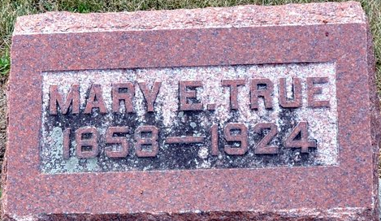
Photo by Deb Curry

Mary E. True
in the Indiana, U.S., Death Certificates, 1899-2017
Name Mary E. True
[Mary E. Lutz]
Gender Female
Race White
Marital Status Married
Age 66
Birth Date 20 Jan 1858
Birth Place Marion Township, Indiana
Death Date 24 Sep 1924
Death Place Poe, Allen, Indiana, USA
Death Registration Date 1924
Father Samuel Lutz
Mother Lucinda Lichtenwalter
Spouse Chas T. True
Informant Chas. True; Fort Wayne, Indiana
Burial September 26, 1924; Decatur Cemetery

