Kathryn True
1870 – December 10, 1944

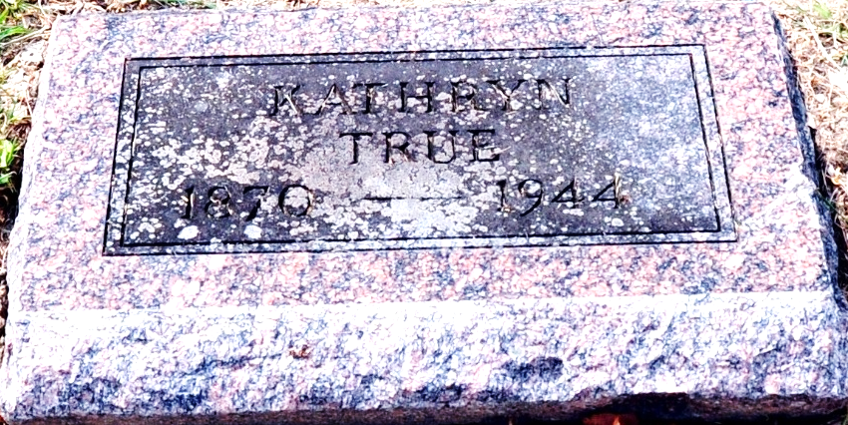
Photo by Deb Curry

Cathryn True
in the Indiana, U.S., Death Certificates, 1899-2017
Name Cathryn True
Gender Female
Race White
Marital Status Divorced
Age abt 65
Birth Date abt 1879
Death Date 10 Dec 1944
Death Place Indianapolis, Marion, Indiana, USA
Death Registration Date 1944
Parents Not listed
Informant None listed
Burial December 13, 1944; Decatur Cemetery; Decatur, Indiana
(Handwritten across death cert: "No one knows anything about family or date of birth - they think she is 65 years old")

