Charles F. True
1854 – January 4, 1935

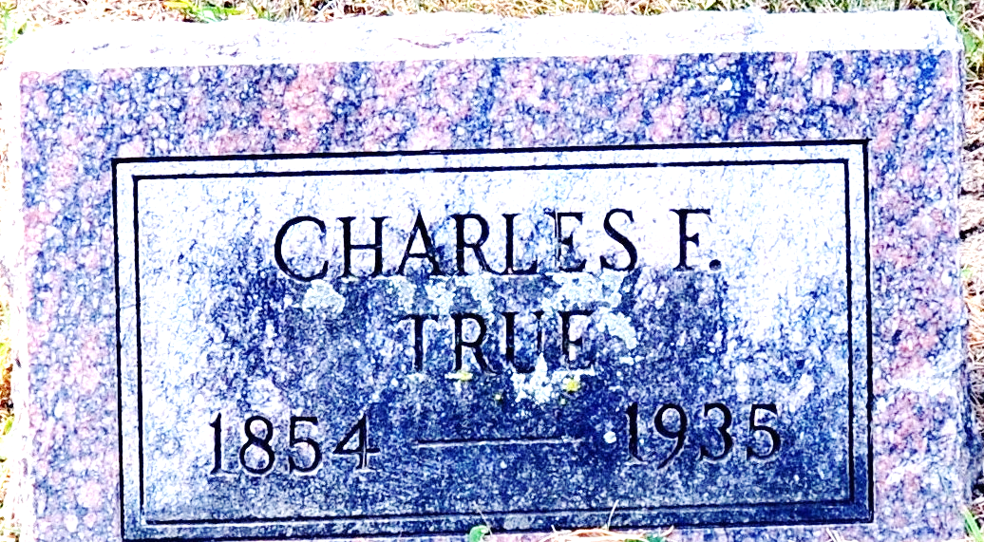
Photo by Deb Curry

Decatur People Attend Funeral
Clark J. Lutz, Mr. and Mrs. Fred Smith and sons, Clark William and Louis went to Winona, Sunday, to attend the funeral services held for Mr. Lutz’s brother-in-law, Charles True. The body was brought to Decatur for burial Sunday afternoon.
Bryce True of Dayton, Ohio, who also attended the services, remained in Decatur over the weekend.
Decatur Daily Democrat; Adams County, Indiana
January 7, 1935

**
CHARLES TRUE DEAD
Charles True, about 80 years of age, a former well known businessman of Decatur, died at his home in Winona at 10 o'clock Friday morning of a heart attack. Mr. True had been ailing for some time. He was formerly in business with Eugene Runyon, former Berne man.
The Berne Review; Adams County, Indiana
January 7, 1935

**
John C. F. True from tree McClellan Family Tree
Birth 1856 Indiana, USA
Residence 1870 Allen, Indiana, USA
Father Herod G. True (Born 1814)
Mother Rebecca Connett (1826-1883)
136396 People 1 Record 1 Source

