Luella May (Brokaw) Troyer
June 7, 1915 – July 4, 2003

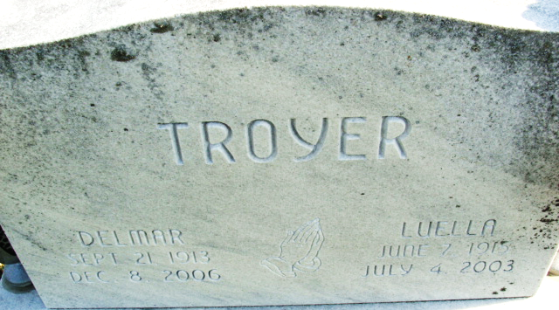
Photo by Alicia Kneuss

Luella May Troyer
in the U.S., Social Security Applications and Claims Index, 1936-2007
Name Luella May Troyer
[Luella May Brokaw]
[Luella Troyer]
Gender Female
Race White
Birth Date 7 Jun 1915
Birth Place Adams, Indiana
Death Date 4 Jul 2003
Father Vesta A Brokaw
Mother Daisy Lewton
SSN xxx
Notes Apr 1950: Name Listed As Luella May Troyer; : Name Listed As Luella May Brokaw; 12 Jul 2003: Name Listed As Luella M Troyer

