Delmar Fred Troyer
September 21, 1913 – December 8, 2006

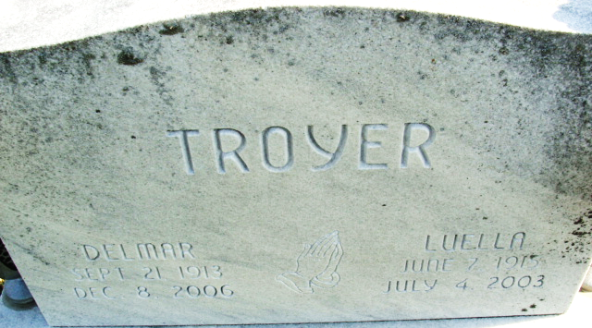
Photo by Alicia Kneuss

Delmar Fred Troyer, 93, of Seymour, Tennessee, died Friday, December 8, 2006, at his residence. A former lifelong resident of the Monroeville area before moving to Tennessee in 1994.
Surviving is his daughter, Jance A. (Steven) Kaiser of Seymour, Tennessee; grandchildren, Melinda (Jim) Thornton, Chad (Regina) Kaiser, Matthew (Sarah) Kaiser, Andrew Kaiser and Jeffery Kaiser; great grandchildren, Wendell Thornton, Mackenzie Thornton and Leslie Kaiser.
Service is 10 am Tuesday at Zwick & Jahn Funeral Home, Jacobs Chapel, Monroeville. Visitation is from 4 to 8 pm today at the funeral home.

Fort Wayne Newspapers, Allen County, Indiana
December 12, 2006

**
Indiana, U.S., Birth Certificates, 1907-1944
Name Delmar F Troyer
Gender Male
Birth Date 21 Sep 1913
Birth Place Monroe, Allen, Indiana, USA
Father O. J. Troyer; age 43
Mother Edna Slonaker; age 39; 6th child, all living
Certificate Number 1978; Roll number 40474_357360
Volume Range 599 - 605
**
U.S., Obituary Collection, 1930-Current
Name Delmar F. Troyer
Death Age 93
Birth Date 21 Sep 1913
Residence Place Seymour, Tennessee
Death Date 8 Dec 2006
Death Place Seymour, Tennessee

