Dr. William T. Trout
March 14, 1817 – July 2, 1884

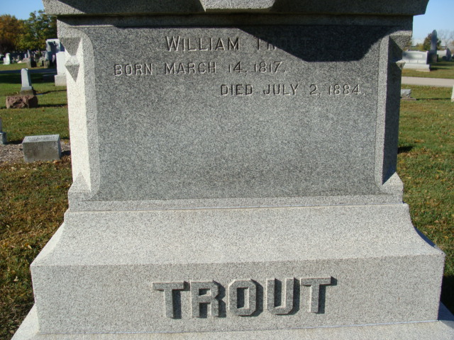
Photo by Alicia Kneuss

Dr William T Trout from tree Rowbotham Family Tree
Birth 14 Mar 1817 Berks, Pennsylvania, USA
Marriage 22 Mar 1842 Adams, Indiana, USA
Residence 1870 Decatur, Adams, Indiana, USA
Death 2 Jul 1884 Decatur, Adams, Indiana, USA
Father Wilhelm Trout 'Traut' (Born 1789)
Mother Susan A Musselman (1790-1856)
Spouse Mary Welch (1820-1901)

