Susan (Hoch) Trout
December 9, 1790 – June 28, 1856

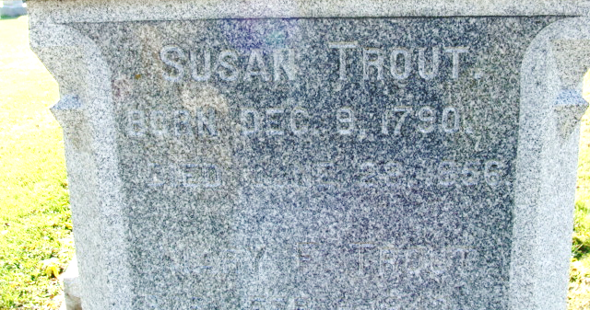
Photo by Alicia Kneuss

Susannah Hoch from tree Terry's Family Tree
Birth 9 Dec 1790 Oley, Berks, Pennsylvania, USA
Marriage 28 Aug 1849 Mason, Illinois, USA
Death 28 Jun 1856 Decatur, Adams, Indiana, USA
Father Samuel Bertolet Hoch (1757-1826)
Mother Hannah Clauser (1767-1849)
Spouse William Trout (1789-1854)

