Mary (Welsh) Trout
November 20, 1820 – November 5, 1901

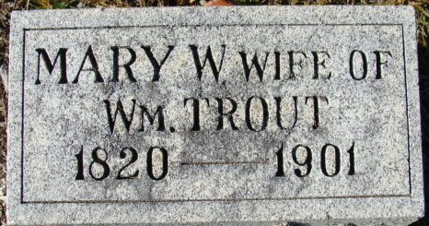
Photo by Alicia Kneuss

At six o'clock Tuesday morning at her home, corner of First and Monroe Streets, occurred the death of Mrs. Mary Welsh Trout, a lady well known to every Decatur citizen, where she has resided for more than half a century. She was rather an eccentric lady but kind and loving with all and was loved by many.
She was born December [sic] 11, 1820, and lacked only a few days of attaining the age of eighty-one. For several years she has been in feeble health but was able to be about most of the time until a few months ago, when her vitality seemed to give out and each day brought the end so much closer.
Dr. D. G. M. Trout, her only son, remains to mourn the loss of mother, the husband having preceded her in death a number of years ago.
Rev. C. G. Hudson will conduct the funeral services which will be held from the Methodist Church at two o'clock this afternoon. Interment at Maplewood Cemetery.
Decatur Democrat; Adams County, Indiana
Thursday, November 7, 1901
**
Indiana, U.S., Death Certificates, 1899-2017
Name Mary Welsh Trout
Gender Female
Race White
Marital Status Widowed
Age 80 years, 11 months, 16 days
Birth Date abt 1821
Birth Place Maryland
Death Date 5 Nov 1901
Death Place Decatur, Adams, Indiana, USA
Father James Welsh
Mother Not named
Informant D. G. M. Trout; Decatur, Indiana
Burial November 7, 1901; Decatur Cemetery
**
Mary Welsh from tree The Simmons Family Tree
Birth 19 Nov 1820 Maryland, USA
Marriage 22 Mar 1842 Adams, Indiana, USA
Residence 1880 Decatur, Adams, Indiana, USA
Death 1 Nov 1901 Decatur, Adams, Indiana, USA
Father James Welsh or Welch (1779-1856)
Mother Ann "Nancy" Dugan
Spouse William T Trout (1817-1884)

