Mariam B. Trout
February 7, 1879 – July 28, 1953

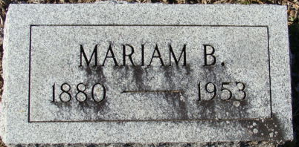
Photo by Alicia Kneuss

Mariam Trout
in the Indiana, U.S., Death Certificates, 1899-2017
Name Mariam Trout
Gender Female
Race White
Marital Status Divorced
Age 74
Birth Date 7 Feb 1879
Birth Place Adams County, Indiana
Death Date 28 Jul 1953
Death Place Decatur, Adams, Indiana, USA
Death Registration Date 1953
Father Dallas Trout
Mother Flora Blackmond
Informant John Trout; Decatur, Indiana
Burial July 29, 1953; Decatur Cemetery; Decatur, Indiana

