Flora B. (Blackmond) Trout
June 20, 1853 – June 6, 1945

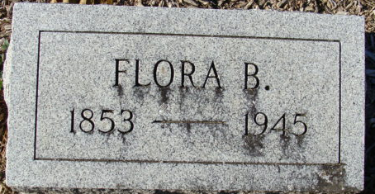
Photo by Alicia Kneuss

Mrs Flora Blackmond Trout
in the Indiana, U.S., Death Certificates, 1899-2017
Name Mrs Flora Blackmond Trout
Gender Female
Race White
Marital Status Widowed
Age 86
Birth Date 20 Jun 1858
Birth Place Otsego Michigan
Death Date 6 Jun 1945
Death Place Decatur, Adams, Indiana, USA
Parents Unknown
Spouse D G M Trout
Informant Mrs. May Wittgenfeldt; Decatur, Indiana
Burial June 10, 1945; Decatur Cemetery; Decatur, Indiana
**
Flora B. Blackmond from tree The Simmons Family Tree
Birth 20 Jun 1852 Otsego, Allegan, Michigan, USA
Marriage 31 Dec 1876 Portland, Jay, Indiana, USA
Residence 1 Apr 1940 Decatur, Adams, Indiana, USA
Death 6 Jun 1945 Decatur, Adams, Indiana, USA
Father Asa. W. Blackmond (1816-1890)
Mother Charlotte M. Hosig
Spouse Dallas G.M. Trout (1846-1928)

