Dallas G. M. Trout
October 8, 1846 – November 29, 1928

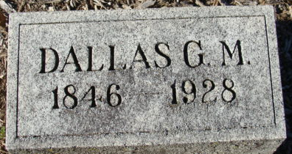
Photo by Alicia Kneuss

Dallas G M Trout
in the Indiana, U.S., Death Certificates, 1899-2017
Name Dallas G M Trout
Gender Male
Race White
Marital Status Married
Age 82
Birth Date 8 Oct 1846
Birth Place Indiana
Death Date 29 Nov 1928
Death Place Decatur, Adams, Indiana, USA
Death Registration Date 1928
Father Wm Trout
Mother Mary Welsh
Spouse Flora B.
Informant Wm. Trout; Decatur, Indiana
Burial December 2, 1928; Decatur Cemetery

