Clara A. (Koenig) Trout-Hummel
June 30, 1913 – March 27, 2001

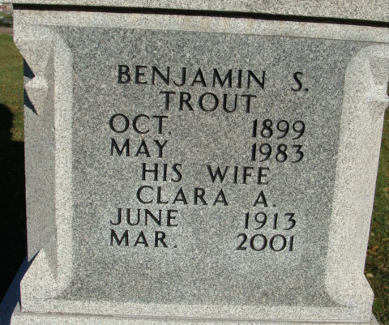
Photo by Alicia Kneuss

Clara A Hummel
in the Indiana, U.S., Death Certificates, 1899-2017
Name Clara A Hummel [Clara A Koenig]
Gender Female
Race White
Age 87
Marital Status Widowed
Birth Date 30 Jun 1913
Birth Place Adams County
Death Date 27 Mar 2001
Death Place Decatur, Adams, Indiana, USA
Father: Frederick Koenig
Mother: Mary M Spangler
Informant: Herman Everett; son; Decatur, Indiana
Burial: March 31, 2001; Decatur Cemetery; Decatur, Indiana
**
U.S., Social Security Applications and Claims Index, 1936-2007
Name Clara Anna Hummel
[Clara A Trout] [Clara Hummel] [Clara Anna Koenig]
Gender Female; Race White
Birth Date 30 Jun 1913, Birth Place Decatur, Indiana
Death Date 27 Mar 2001
Claim Date 2 Apr 1975
Father Fred Koenig; Mother Mary M Spangler
SSN xxxx; Citizenship or Alien Status U.S. citizen.
Type of Claim Duplicate request; evidence of identity only submitted.
Signature on SSN Card Clara Anna Everett
Notes 14 Aug 1986: Name listed as CLARA ANNA HUMMEL; 01 Apr 1975: Name listed as CLARA A TROUT; 06 Apr 2001: Name listed as CLARA A HUMMEL

