Benjamin S. Trout
October 15, 1899 – May 18, 1983

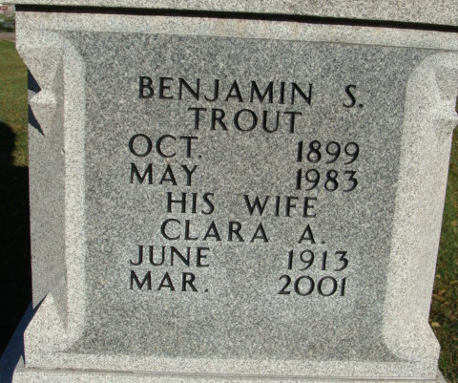
Photo by Alicia Kneuss

Benjamin S. Trout
in the Indiana, U.S., Death Certificates, 1899-2017
Name Benjamin S. Trout
Gender Male
Race White
Marital Status Married
Age 83
Birth Date 15 Oct 1899
Birth Place Indiana
Death Date 18 May 1983
Death Place Decatur, Adams, Indiana, USA
Death Registration Date 1983
Father William B. Trout
Mother Edna H. Hertz
Spouse Clara Koenig
Informant Mrs. Clara Trout; wife; Decatur, Indiana
Burial May 20, 1983; Decatur Cemetery; Decatur, Indiana

