Myrtle E. “Mertie” (Valentine) Tritch
August 17, 1878 – December 22, 1934

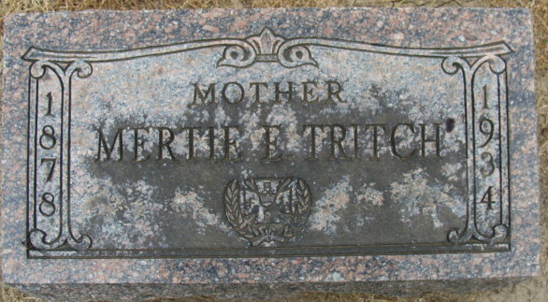
Photo by Alicia Kneuss

MRS. J. C. TRITCH CLAIMED BY DEATH
Short Illness is Fatal to Wife of Principal of International College
Mrs. Myrtle Tritch, aged 56, 1227 Nuttman Avenue, wife of Jonas C. Tritch, who is principal of the International College here, died at 1:35 a.m. today at the Lutheran Hospital, where she underwent a major abdominal operation Monday. Mrs. Tritch was taken seriously ill last Sunday night and was taken to the hospital Monday morning. She and her husband last Sunday visited friends in Decatur, where they resided before coming to this city 20 years ago.
Funeral services will be held Monday afternoon at 2 o'clock at the First Methodist Episcopal Church in Decatur, with Dr. E. Burns Martin, pastor of the Wayne Street M.E. Church, officiating. Burial will be in the Maplewood Cemetery at Decatur. The funeral party will leave Klaehn & Sons' Funeral Home by motor Monday at 1 p.m.
Surviving, besides the husband, are a son, Max Allen Tritch, a senior in South Side High School; the mother, Mrs. Reuben Valentine, of Monroe; two sisters, Mrs. Sherman Essex of Monroe and Mrs. Fred Zurcher, of Berne; and a brother, Allen Valentine, of DeWitt, Ark.
Mrs. Tritch was a member of the Wayne Street M.E. Church and of the Pythian Sisters Lodge at Decatur. She was born in Circleville, O.

Adams County, Indiana Historical Society Scrapbook
1935 Scrapbook, image 56-57
Handwritten date: Saturday, December 22, 1934
**

Indiana, Death Certificates, 1899-2011
Name: Myrtle Tritch
[Myrtle Valentine]
Gender: Female
Race: White
Age: 56
Marital status: Married
Birth Date: 17 Aug 1878
Birth Place: Kirkville, Ohio
Death Date: 22 Dec 1934
Death Place: Ft. Wayne, Allen, Indiana, USA
Father: Reuban Valentine
Mother: Emeline Spangler
Spouse: Jonas C. Tritch
Informant: Jonas C. Tritch
Burial: Dec. 24, 1934; Decatur Cem.

