Robert L. Tripp
March 14, 1944 - September 8, 2015

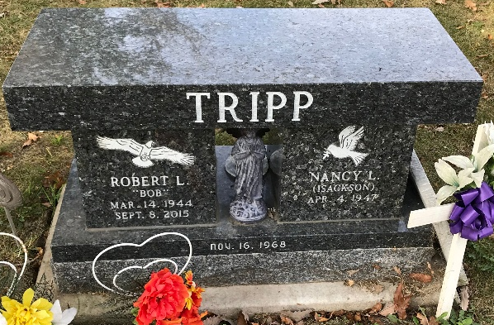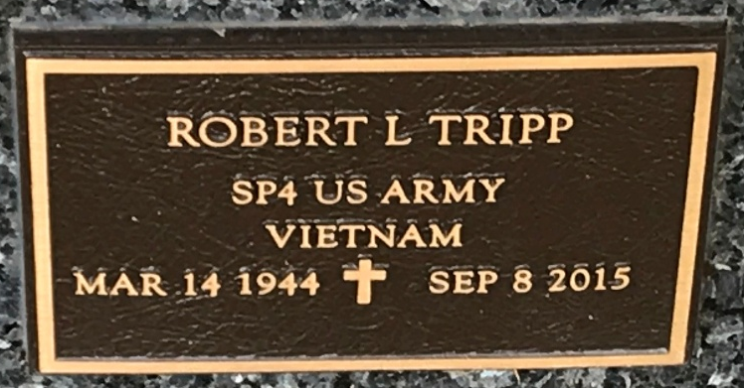
Photos by PLS

Robert L. Tripp, 71 years old of Decatur, Indiana, passed away on Tuesday, September 8, 2015 at his residence following an extended illness. He was born on Tuesday, March 14, 1944 in Rockford, Illinois the son of the late Isaac V. Tripp and the late Roberta (Carpenter) Tripp. He married Nancy Isackson on September 16, 1968 in Beloit, Wisconsin.
Bob served in the United States Army from 1962 to 1965 and was deployed to West Germany. He was a member of Zion Lutheran Church in Decatur and also enjoyed his time coaching youth baseball in Decatur. Bob retired from General Motors in Fort Wayne after 28 years of service on the assembly line. Following his retirement, he worked at Custom Car Care in Decatur.
Surviving are his wife, Nancy Tripp of Decatur; daughter, Kimberly (Troy) Fuhrmann of Decatur; daughter, Nichelle (Randy) Lee of Grover Hill, OH; son, Michael Tripp of Bakersfield, CA; and brother, Phillip (Margaret) Tripp of Westchester, PA. He is also survived by six grandchildren, Kyle Fuhrmann, Tori Fuhrmann, Alyssa Tripp, Dylan Lee, Brittany Lee, and Randall Lee Jr. one great-grandson, Mason J. Gardiner.
Funeral services will be held at 11:00 a.m. Monday, September 14, 2015 in the Zwick & Jahn Funeral Home in Decatur with Rev. Timothy Carr officiating. Friends will be received from 12 noon to 3 p.m. and 4 to 6 p.m., Sunday, September 13 in the Zwick & Jahn Funeral Home in Decatur.
Preferred memorials are to the Fort Wayne Children's Zoo.

Zwick & Jahn Funeral Home, Adams County, Indiana
September 9, 2015

