Warren Henry Trimm
January 25, 1913 – January 17, 1956

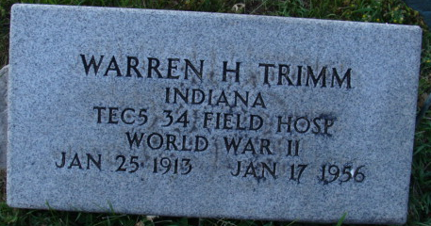
Photo by Alicia Kneuss

Warren H. Trimm Dies Tuesday Night
Warren H. Trimm, 42, of Fort Wayne, died suddenly last night. He was a veteran of World War II. Survivors include his wife, the former Martha Summers of Decatur; two daughters, Mrs. Dwight Gallimore of Pretty Lake and Mrs. Robert Clark of Columbus, O.; a step-daughter, Beverly Foulk of Fort Wayne; three sisters, Mrs. Martin Zezula of Warren, Mrs. Lucile Smitley of Fort Wayne and Mrs. Charles Ladig of New Haven, and three brothers, Virgil, Joseph and Bernard, all of Fort Wayne. Funeral service will be held at 1:30 p. m Friday at the Klaehn Funeral Home in Fort Wayne, with burial in the Decatur Cemetery between 2:30 and 3 p.m.
Decatur Daily Democrat, Adams County, Indiana
Tuesday, January 18, 1956
**

Indiana, U.S., Birth Certificates, 1907-1944
Name Henry Trim
Gender Male
Birth Date 25 Jan 1913
Birth Place Washington, Adams, Indiana, USA
Father Wm Trim; age 36
Mother Ella Hill; age 33; 4 children, all living
Certificate Number 37; Roll number 40474_357396
Volume Range 599 - 603
**

U.S. World War II Army Enlistment Records, 1938-1946
Name: Warren H Trimm
Birth Year: 1913 ; Race: White, citizen (White)
Nativity State or Country: Indiana; State of Residence: Indiana
Enlistment Date: 11 Jan 1943; Enlistment State: Toledo, Ohio
Branch: Branch Immaterial - Warrant Officers, USA; Grade: Private
Term of Enlistment: Enlistment for the duration of the War or other emergency, plus six months, subject to the discretion of the President or otherwise according to law
Component: Selectees (Enlisted Men); Source: Civil Life
Education: Grammar school; Civil Occupation: Sales clerks
Marital Status: Married; Height: 68; Weight: 150

