Wilma Marguerite Trim
January 29, 1904 – March 27, 1905

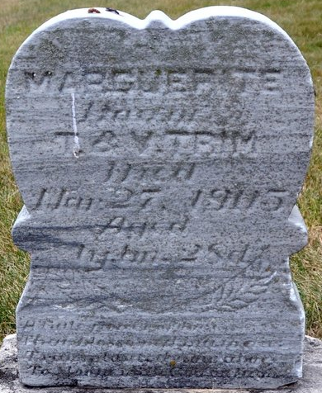
Photo by Deb Curry

Wilma Margeurite Trine
in the Indiana, U.S., Death Certificates, 1899-2017
Name Wilma Margeurite Trim
Gender Female
Race White
Marital Status Single
Age 1
Birth Date 29 Jan 1904
Birth Place Adams, Indiana
Death Date 27 Mar 1905
Death Place Decatur, Adams, Indiana, USA
Death Registration Date 1905
Father Tomy H Trim
Mother Marthia V Gilbert
Informant Thomas H. Trim; Decatur, Indiana
Burial March 29, 1905; Decatur Cemetery

