William H. Trim
June 28, 1876 – May 12, 1951

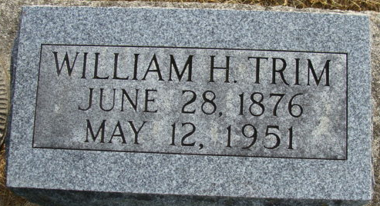
Photo by Alicia Kneuss

William Trim
in the Indiana, U.S., Death Certificates, 1899-2017
Name William Trim
Gender Male
Race White
Marital Status Widowed
Age 74
Birth Date 28 Jun 1876
Birth Place Adams Co, Indiana
Death Date 12 May 1951
Death Place Fort Wayne, Allen, Indiana, USA
Death Registration Date 1951
Father John Trim
Mother Unknown [sic - Eliza Alguire]
Informant Virgil Trimm; Fort Wayne, Indiana
Burial May 15, 1951; Maplewood Cemetery; Decatur, Indiana

