Sarah (Alguire) Trim
May 30, 1832 – July 4, 1914

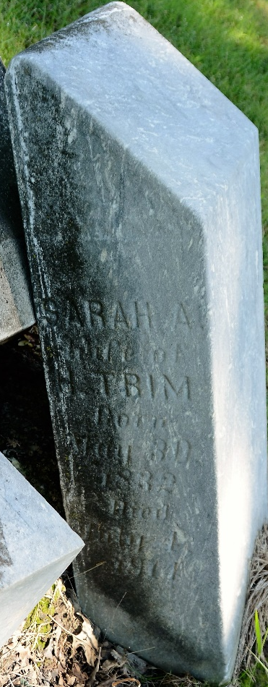
Photo by Deb Curry

Sarah Tim
in the Indiana, U.S., Death Certificates, 1899-2017
Name Sarah A. Trim [Sarah Alguire]
Gender Female
Race White
Marital Status Married
Age 82
Birth Date 30 May 1832
Birth Place Pennsylvania
Death Date 4 Jul 1914
Death Place Decatur, Adams, Indiana, USA
Death Registration Date 1910-1919
Father Michael Alguire
Mother Margaret Miller
Spouse Henry Trim
Informant Jacob Trim; Van Wert, Ohio
Burial July 6, 1914; Decatur Cemetery

