Mary Ella (Hill) Trim
January 22, 1882 – December 17, 1935

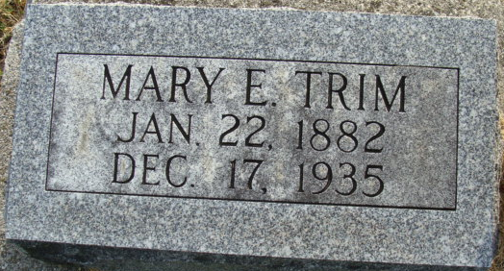
Photo by Alicia Kneuss

FORMER LOCAL WOMAN KILLED
Mrs. William Trim Fatally Injured In Accident Tuesday
Mrs. Ella Mary Trim, 53, Fort Wayne, sister of Charles, George and Henry Hill of Decatur, was killed almost instantly in an automobile collision in Huntington County Tuesday afternoon. Her daughter, Mrs. Lucile Smitley, near Roanoke, suffered rib fractures and numerous cuts and bruises.
Cars driven by Marshall Smitley, son-in-law of the dead woman, and Walter Farrar, Rockcreek Center, collided, overturning the Smitley auto. Smitley and Farrar were uninjured. Also riding in the Smitley auto were Mrs. Luella Trim and her three-months old daughter, neither of whom was badly injured.
Mrs. Trim was born in Decatur and had resided in Fort Wayne for several years.
Survivors include the husband, William; four sons, Bernard, at home, and Virgil, Warren and Joseph of Fort Wayne; three daughters, Mrs. Smitley, Mrs. Leota Zegula (sic) of Salamonie Township, Huntington County and Miss Marjorie Trim at home; a sister, Mrs. Anna Case of Marion; five brothers, Charles, George and Henry Hill of Decatur and Daniel and Grover Hill of Fort Wayne.
Funeral services will be held at Klaehn and Sons Funeral Home at Fort Wayne Friday afternoon at 1 o'clock and the body will then be brought to Decatur for services at the United Brethren Church at 1 p.m. Burial will be made in the Decatur Cemetery.
Decatur Daily Democrat, Adams County, Indiana
Wednesday, December 18, 1935
**
Ella Mary Trim
in the Indiana, U.S., Death Certificates, 1899-2017
Name Ella Mary Trim
[Ella Mary Hill]
Gender Female
Race White
Marital Status Married
Age 53
Birth Date ? Jan 1882
Birth Place Decatur, Indiana
Death Date 17 Dec 1935
Death Place Rock Creek, Huntington, Indiana, USA
Death Registration Date 1935
Father Joseph Hill
Mother Unlisted [Hannah Coleman]
Spouse William H Trim
Informant William Trim; Fort Wayne, Indiana
Burial December 20, 1935; Decatur, Indiana

