Katie (Reader) Trim
June 5, 1894 – December 30, 1923

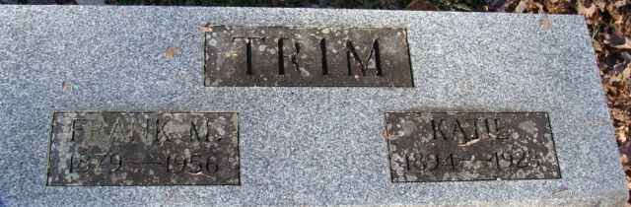
Photo by Alicia Kneuss

Mrs Katie Trein
in the Indiana, U.S., Death Certificates, 1899-2017
Name Mrs Katie Trim
[Katie Reader]
Gender Female
Race White
Marital Status Married
Age 29
Birth Date 5 Jun 1894
Birth Place Indiana
Death Date 30 Dec 1923
Death Place Fort Wayne, Allen, Indiana, USA
Death Registration Date 1923
Father Geo. Reader
Mother Ellen Shideler
Spouse Frank Trim
Informant Frank Trim; Fort Wayne, Indiana
Burial January 2, 1924; Decatur, Indiana

